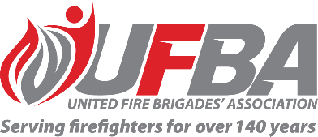
Expression of Interest Form for:
UFBA Working Group – FENZ Volunteer Payments Project
Group Overview | This Working Group aims to draw on the expertise of our membership to provide early input into the FENZ Volunteer Payments Project, to understand how these payments are experienced and understood from their perspectives.  Project overview:  Fire and Emergency New Zealand has a range of payment mechanisms to reimburse and support volunteers. These mechanisms are sometimes unclear for volunteers, while Fire and Emergency must ensure that payment arrangements remain appropriate, consistently applied and aligned with contemporary volunteering and organisational expectations. Therefore, a review of volunteer payment arrangements is required to improve clarity, consistency, and confidence in the system for both volunteers and the organisation.  Scope Includes:  - Volunteer Annual Reimbursement  - Family / Whānau Support Allowance  - Loss of Income  - Volunteer Gratuities  - Individual legacy payments  - Long Duration Incident Payments
Date open | 09/04/2026 | Date closes | 20/04/2026
Working Group Member Requirements
Expertise & Experience | We are looking for a wide range of members from diverse backgrounds and experiences as the payments in scope affect all volunteers in different ways. Any relevant external experience will be strongly considered.
Commitment | Group members will be required to meet regularly and provide verbal and written feedback or input as requested. The expected formal consultation is during mid to late 2026.

Your Details
Name |  | Brigade, Rank/Role
Phone |  | Email
Please describe your interest in the Volunteer Payments Project and the UFBA Working Group.

Please describe your expertise and/or experience relevant to the Volunteer Payments Project.

We recommend attaching your CV if you are referring to external experience.

Please return this form by the close date 20 April 2026 to connect@ufba.org.nz

