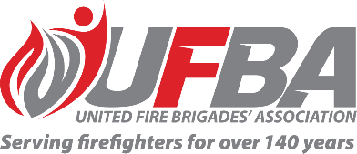
Expression of Interest Form for:
UFBA Volunteer Field Experts – Rank & Role
Group Overview | This Volunteer Field Expert Group aims to provide a forum that values and acknowledges the expertise within UFBA membership and better enables the UFBA to draw on this expertise, with a focus on Rank & Role for the primary purpose of providing input into the FENZ consultations processes on this project.  Rank & Role project background:  FENZ are formalising consultation with the UFBA in accordance with Section 36 (1) (b) of the Fire and Emergency New Zealand Act 2017 and Agreements with Fire and Emergency New Zealand.  Between 2024 and 2025, Fire and Emergency and representatives of the UFBA have engaged in discussions regarding the Rank and Role Project. This Project aims to revise and unify rank policies, frameworks, and procedures across both volunteer built and natural brigades. It also seeks to address the inconsistencies in uniformed positions and ranks within Fire and Emergency.  To date Fire and Emergency has:  - Completed initial scoping and planning of the project.  - Shared high-level information and the proposed approach.  - Collaborated with representatives nominated by the UFBA on the design and planning of the initiatives.  This collaborative effort has resulted in an updated programme of work consisting of 6 initiatives. Further consultation will be undertaken over the coming months as the programme progresses.
Date open | 21/10/2025 | Date closes | 11/11/2025
Individual Requirements
Expertise & Experience | Preference will be given to candidates who have:  - Interest, knowledge and experience in FENZ’s current rank and role structures.  - The ability to understand and represent the UFBA’s diverse wider membership.  - The ability to work collaboratively and professionally to achieve a great outcome for all parties.  - Advantageous to have:  - External experience of any other emergency service, public sector or private sector organisational and/or command structure.
Commitment | Group members will be required to convene on an as-required basis, depending on FENZ’s request for input into the project’s stages.

Your Details
Name |  | Brigade, Rank/Role
Phone |  | Email
Please describe your expertise relevant to the requirements of this group. We recommend attaching your CV if you are referring to external experience.

Please describe your experience/interest relevant to the requirements of this group. We recommend attaching your CV if you are referring to external experience.

Please return this form by the close date to connect@ufba.org.nz

