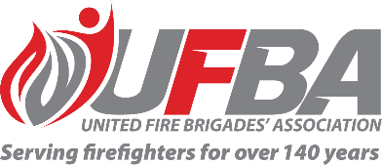
Expression of Interest Form for:
UFBA Volunteer Member Field Experts Group – HAUORA (Safety, Health and Wellbeing)
Group Overview | Purpose  This group aims to provide a forum that values, acknowledges and utilises the expertise within UFBA membership and better enables the UFBA to draw on this specialised knowledge, with a focus on Hauora (Safety, Health and Wellbeing).  To strengthen the voice of our membership and demonstrate our members’ expertise to influence sector-wide policy and changes over time, especially where changes could impact the delivery of fire and emergency services in local communities.  The UFBA wants to ensure brigades are well-supported by FENZ to serve and protect their communities, and that any changes or implementation is made with the advice of volunteers.  Objectives:  - Raise with the UFBA opportunities for improvement regarding hauora (safety, health and wellbeing).  - Review, discuss and provide feedback or advice on FENZ policies and procedures that affect volunteer hauora.
Date open | 5 February 2025 | Date closes | 23 February 2025
UFBA Volunteer Field Expert Requirements:
Expertise and Experience | Preference will be given to candidates who have:  - Specialised knowledge and experience in the area of physical or mental wellbeing.  - Knowledge of FENZ’s safety, health and wellbeing policies and processes current state  - The ability to represent the UFBA’s diverse wider membership.  - The ability to work collaboratively and professionally to achieve a great outcome for all parties.  - Advantageous to have:  - A medical qualification, HR experience, health and safety in workplace management, or risk reduction experience.  - Completed research and aware of new innovations in hauora that may be of use in New Zealand and Internationally.
Commitment | - Online meetings as required  - Document review  - Written feedback  - Group discussions

Your Details
Name |  |  | Brigade, Rank/Role
Phone |  |  | Email
Your Experience
Please describe your knowledge and experience in the area of physical or mental wellbeing.

Please describe your knowledge of FENZ’s safety, health and wellbeing policies and processes current state
Do you have any other experience or knowledge that would be beneficial for the purpose of this group? (ie. qualifications, work experience, related expertise). If yes, please describe.
Have you previously been part of any UFBA, FENZ, or other sector-related working group? If yes, please describe your involvement and representation.

Please return this form by Sunday 23 February 2025 to connect@ufba.org.nz

