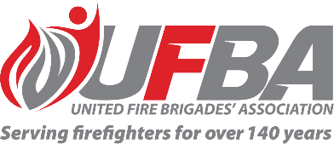

Expression of Interest for UFBA Representative

|  |  |  |  |
| --- | --- | --- | --- |
| **Seeking UFBA Representative for:** | | **FENZ Risk Reduction Training Sprint Group** | |
| **About** | This group will provide advice and guidance to the project team on the high-level design of a training programme for staff with risk reduction functions.  The terms of reference will be agreed upon during the first meeting of the advisory group. | | |
| **Date opened** | 12 December 2024 | **Date closes** | 17 December 2024 |
| **Representative Requirements** | | | |
| **Experience** | * have an understanding of risk reduction functions and roles of FENZ volunteer and paid personnel * be able to constructively participate in meetings, * give unbiased views and feedback that represent the membership, and, * report back to the UFBA | | |
| **Commitment** | The group will meet monthly from January through to June 2025 | | |

|  |  |  |  |
| --- | --- | --- | --- |
| **Your Details** | | | |
| **Name** |  | **Brigade, Rank/Role** |  |
| **Phone** |  | **Email** |  |
| Please describe your experience/interest relevant to the requirements of this advisory group:  *Please return this form by the close date to* [*connect@ufba.org.nz*](mailto:connect@ufba.org.nz) | | | |