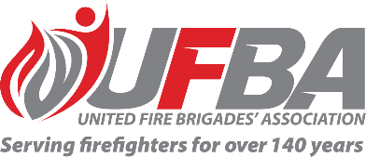
Expression of Interest Form for:
UFBA Volunteer Member Field Experts Group – APPLIANCE FLEET
Group Overview | Purpose  This group aims to provide a forum that values, acknowledges and utilises the expertise within UFBA membership and better enables the UFBA to draw on this specialised knowledge, with a focus on Fleet.  To strengthen the voice of our membership and demonstrate our members’ expertise to influence sector-wide policy and changes over time, especially where changes could impact the delivery of fire and emergency services in local communities.  The UFBA wants to ensure brigades are well-supported by FENZ to serve and protect their communities, and that any changes or implementation is made with the advice of volunteers.  Objectives:  - Raise with the UFBA opportunities for improvement regarding fleet and appliances.  - Review, discuss and provide feedback or advice on operational/technical requirements and suitability of fleet and appliances.  - Review, discuss and provide feedback or advice on FENZ policies and procedures that affect fleet and appliances.
Date open | 15 November 2024 | Date closes | 13 December 2024
UFBA Volunteer Field Expert Requirements:
Expertise and Experience | Preference will be given to candidates who have:  - Specialised knowledge and experience in the use and operation of fire appliances.  - Basic knowledge of fire science (physics, hydraulics, mechanics, or similar).  - Advantageous to have:  - Completed research and aware of new innovations that may be of use in New Zealand.  - An understanding of the operations of large heavy vehicle fleets.  - The ability to represent the UFBA’s wider membership.  - The ability to work collaboratively to achieve a great outcome for all parties.
Commitment | - Online meetings as required  - Document review  - Written feedback  - Group discussions

Your Details
Name |  |  | Brigade, Rank/Role
Phone |  |  | Email
Your Experience
Please describe your knowledge and experience in the use and operation of fire appliances.
Please describe your knowledge of fire science
(ie. physics, hydraulics, mechanics, or similar).
Do you have any other experience or knowledge that would be beneficial for the purpose of this group? (ie. truck fleet operation and maintenance, research, innovation). If yes, please describe.
Have you previously been part of any UFBA, FENZ, or other sector-related working group? If yes, please describe your involvement and representation.

Please return this form by COB Friday 13 December 2024 to connect@ufba.org.nz

